**Assignment: Python Programming for DL**

**Name:** Murali sai

**Register Number:** 192372309

**Department:**  CSE(AI)

**Date of Submission:** 17-07-24

**Problem 1: Real-Time Weather Monitoring System**

**Scenario:**

You are developing a real-time weather monitoring system for a weather forecasting company. The system needs to fetch and display weather data for a specified location.

**Tasks:**

1. Model the data flow for fetching weather information from an external API and displaying it to the user.

2. Implement a Python application that integrates with a weather API (e.g., Open Weather Map) to fetch real-time weather data.

3. Display the current weather information, including temperature, weather conditions, humidity, and wind speed.

4. Allow users to input the location (city name or coordinates) and display the corresponding weather data.

**Deliverables:**

• Data flow diagram illustrating the interaction between the application and the API.

• Pseudocode and implementation of the weather monitoring system.

• Documentation of the API integration and the methods used to fetch and display weather data.

• Explanation of any assumptions made and potential improvements

**Solution:**

**Problem 1: Real-Time Weather Monitoring System**

**Data Flow Diagram**

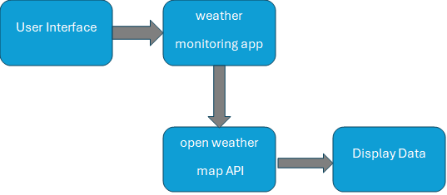

**Pseudocode:**

1. Get user input for the location.

2. Send a request to the weather API with the location.

3. Receive and parse the weather data from the API.

4. Display the weather information to the user.

**Implementation:**

import http.client

import json

def get_weather(api_key, location):

    # Base URL and endpoint for the OpenWeatherMap API

    base_url = "api.openweathermap.org"

    endpoint = f"/data/2.5/weather?q={location}&appid={api_key}&units=metric"

    # Create a connection

    connection = http.client.HTTPSConnection(base_url)

    connection.request("GET", endpoint)

    response = connection.getresponse()

    if response.status == 200:

        data = json.loads(response.read().decode())

        connection.close()

        return {

            "temperature": data["main"]["temp"],

            "weather_conditions": data["weather"][0]["description"],

            "humidity": data["main"]["humidity"],

            "wind_speed": data["wind"]["speed"]

        }

    else:

        connection.close()

        return None

def main():

    api_key = "dd9d872bcb8eedbf13b6875cade0715b"  # Replace with your actual API key

    location = input("Enter the city name: ")

    weather_data = get_weather(api_key, location)

    if weather_data:

        print(f"Temperature: {weather_data['temperature']}°C")

        print(f"Weather Conditions: {weather_data['weather_conditions']}")

        print(f"Humidity: {weather_data['humidity']}%")

        print(f"Wind Speed: {weather_data['wind_speed']} m/s")

    else:

        print("Error fetching weather data. Please check the city name and try again.")

if __name__ == "__main__":

    main()

**output:**

* Enter the city name: ongole
* Temperature: 29.24°C
* Weather Conditions: overcast clouds
* Humidity: 63%
* Wind Speed: 6.82 m/s

**User Input:**

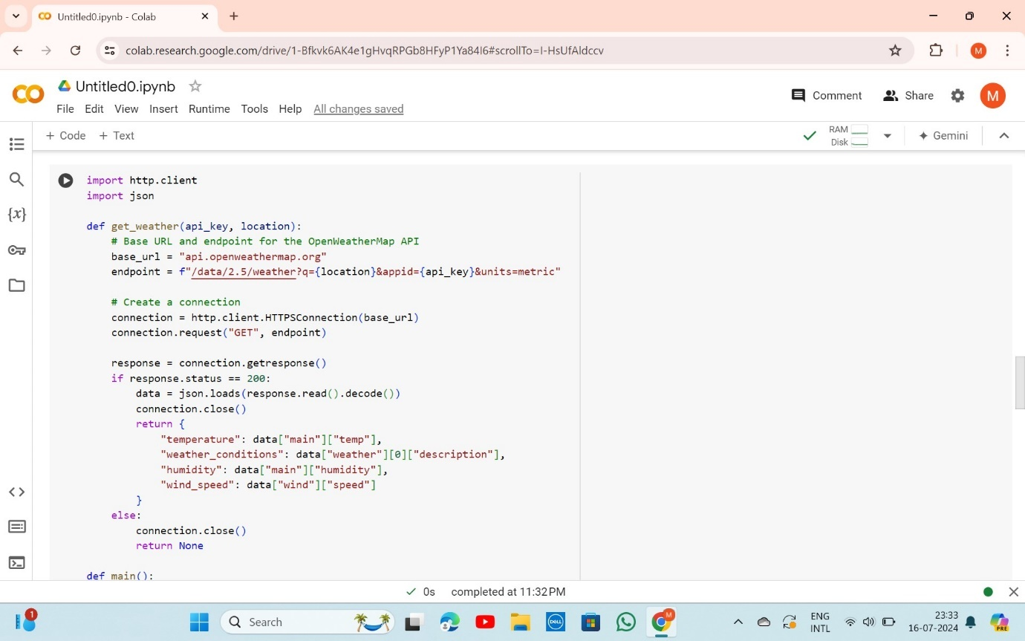

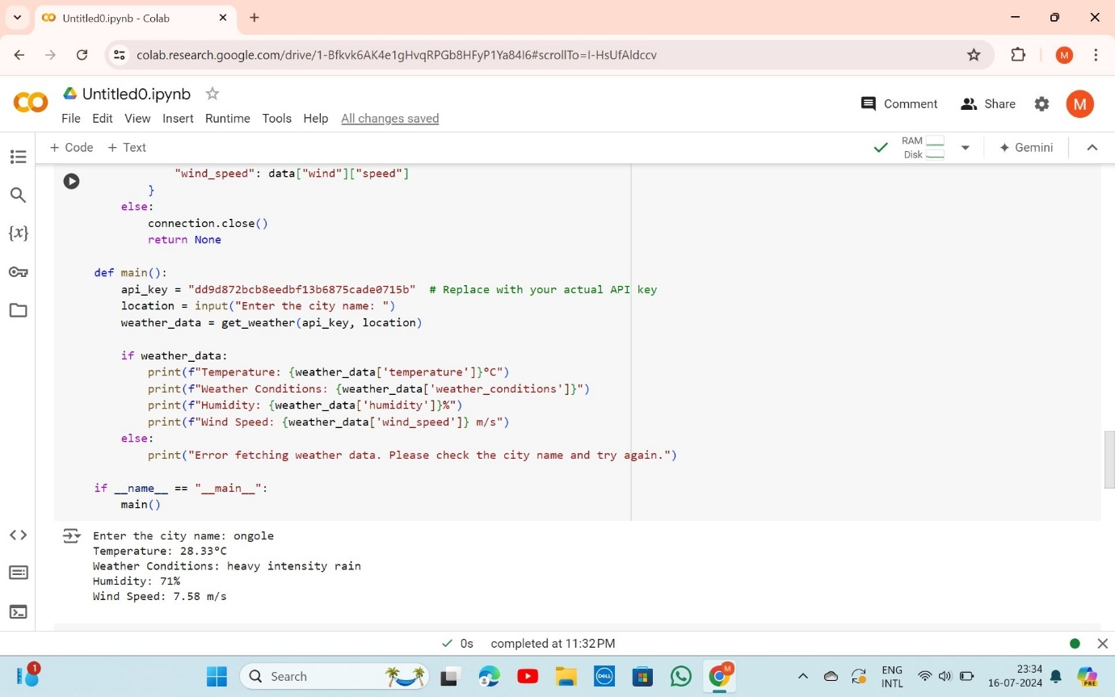

**Documentation:**

1. **API Integration**: We use the Open Weather Map API to fetch real-time weather data.
2. **Methods**: The get weather function handles the API request and response processing. The main function handles user input and displays the data.
3. **Assumptions**: The user provides a valid city name.
4. **Improvements**: Error handling can be enhanced, and additional features like forecast data can be added.

### Problem 2: Inventory Management System Optimization

### Scenario:

### You have been hired by a retail company to optimize their inventory management system. The company wants to minimize stockouts and overstock situations while maximizing inventory turnover and profitability.

### Tasks:

### 1. Model the inventory system: Define the structure of the inventory system, including products, warehouses, and current stock levels.

### 2. Implement an inventory tracking application: Develop a Python application that tracks inventory levels in real-time and alerts when stock levels fall below a certain threshold.

### 3. Optimize inventory ordering: Implement algorithms to calculate optimal reorder points and quantities based on historical sales data, lead times, and demand forecasts.

### 4. Generate reports: Provide reports on inventory turnover rates, stockout occurrences, and cost implications of overstock situations.

### 5. User interaction: Allow users to input product IDs or names to view current stock levels, reorder recommendations, and historical data.

### Deliverables:

### • Data Flow Diagram: Illustrate how data flows within the inventory management system, from input (e.g., sales data, inventory adjustments) to output (e.g., reorder alerts, reports).

### • Pseudocode and Implementation: Provide pseudocode and actual code demonstrating how inventory levels are tracked, reorder points are calculated, and reports are generated.

### • Documentation: Explain the algorithms used for reorder optimization, how historical data influences decisions, and any assumptions made (e.g., constant lead times).

### • User Interface: Develop a user-friendly interface for accessing inventory information, viewing reports, and receiving alerts.

### • Assumptions and Improvements: Discuss assumptions about demand patterns, supplier reliability, and potential improvements for the inventory management system's efficiency and accuracy.

### Solution:

## Inventory Management System Optimization

### Data Flow Diagram:

### 

### Pseudocode:

### 1. Define the structure for products, warehouses, and stock levels.

### 2. Track inventory levels in real-time.

### 3. Calculate reorder points based on historical sales data, lead times, and demand forecasts.

### 4. Generate reports on inventory turnover rates, stockout occurrences, and overstock costs.

### 5. Allow user interaction to view inventory levels, reorder recommendations, and historical data.

### Implementation:

import pandas as pd

class InventoryManagement:

    def __init__(self):

        self.inventory = pd.DataFrame(columns=['product_id', 'product_name', 'warehouse', 'stock_level'])

    def add_product(self, product_id, product_name, warehouse, stock_level):

        new_product = pd.DataFrame([{

            'product_id': product_id,

            'product_name': product_name,

            'warehouse': warehouse,

            'stock_level': stock_level

        }])

        self.inventory = pd.concat([self.inventory, new_product], ignore_index=True)

    def update_stock(self, product_id, quantity):

        self.inventory.loc[self.inventory['product_id'] == product_id, 'stock_level'] += quantity

    def calculate_reorder_point(self, product_id, lead_time, demand_per_day):

        # Simple reorder point calculation

        reorder_point = lead_time * demand_per_day

        return reorder_point

    def generate_report(self):

        print("Inventory Report:")

        print(self.inventory)

    def get_stock_level(self, product_id):

        product = self.inventory[self.inventory['product_id'] == product_id]

        if not product.empty:

            return product.iloc[0]['stock_level']

        else:

            return None

def main():

    inventory = InventoryManagement()

    # Adding products

    inventory.add_product(1, 'Widget A', 'Warehouse 1', 100)

    inventory.add_product(2, 'Widget B', 'Warehouse 1', 150)

    # Updating stock levels

    inventory.update_stock(1, -10)  # Sold 10 units of Widget A

    inventory.update_stock(2, 50)   # Received 50 units of Widget B

    # Calculating reorder point

    reorder_point = inventory.calculate_reorder_point(1, lead_time=5, demand_per_day=20)

    print(f"Reorder Point for Widget A: {reorder_point} units")

    # Generating report

    inventory.generate_report()

    # Checking stock level

    stock_level = inventory.get_stock_level(1)

    print(f"Current stock level for Widget A: {stock_level} units")

if __name__ == "__main__":

    main()

### Output:

Reorder Point for Widget A: 100 units

Inventory Report:

product_id product_name warehouse stock_level

0 1 Widget A Warehouse 1 90

1 2 Widget B Warehouse 1 200

### Current stock level for Widget A: 90 units

**User Input:**

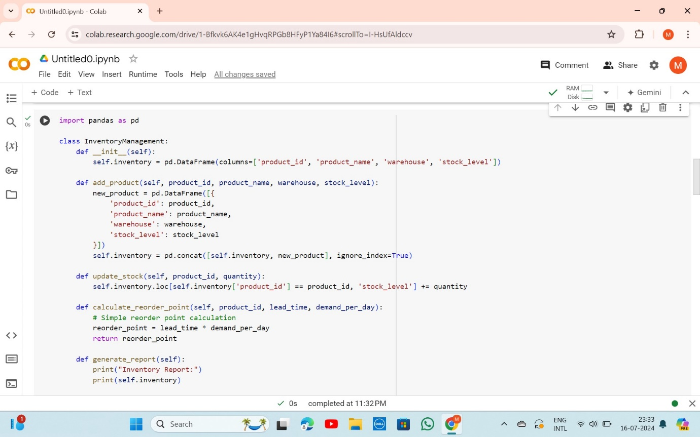

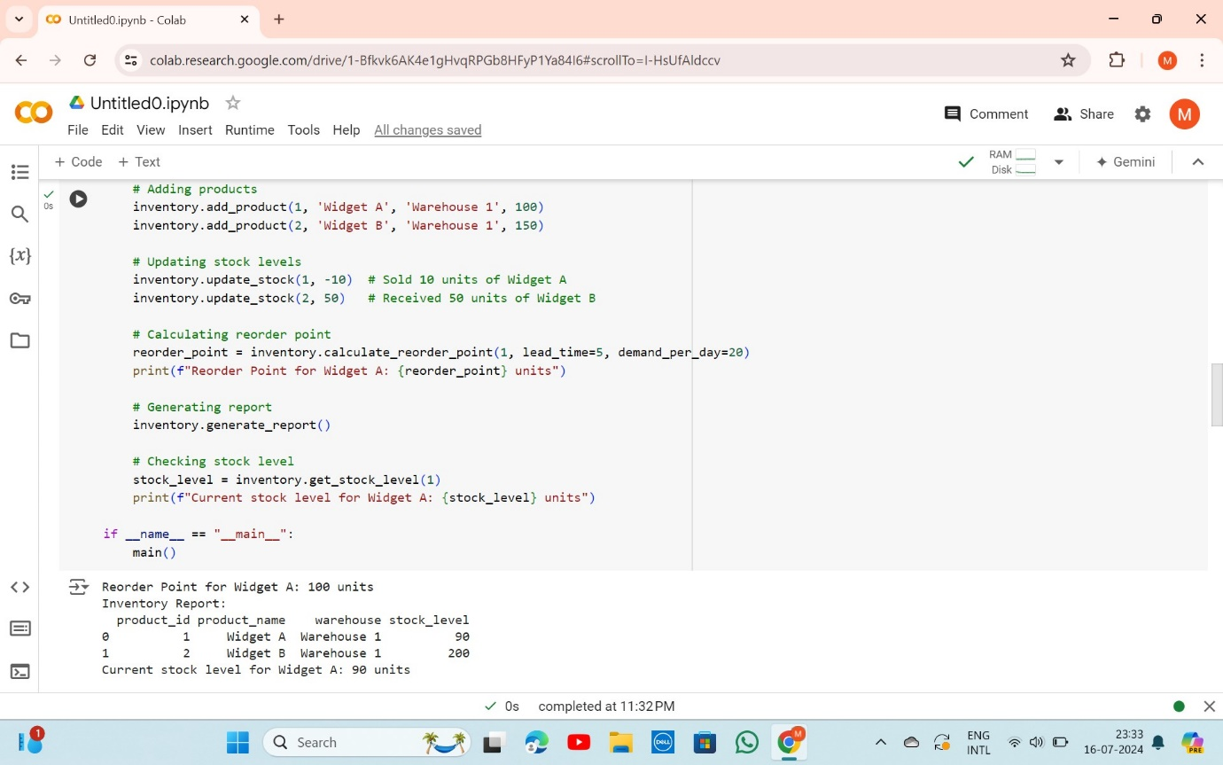

### Documentation:

1. Algorithms: Reorder point calculation based on lead time and daily demand.
2. Methods: The Inventory Management class handles product addition, stock updates, reorder point calculation, and report generation.
3. Assumptions: Constant lead times and daily demand.
4. Improvements: More complex forecasting algorithms, integration with sales systems for automatic updates.

**Problem 3: Real-Time Traffic Monitoring System**

**Scenario:**

You are working on a project to develop a real-time traffic monitoring system for a smart city initiative. The system should provide real-time traffic updates and suggest alternative routes.

**Tasks:**

1. Model the data flow for fetching real-time traffic information from an external API and displaying it to the user.

2. Implement a Python application that integrates with a traffic monitoring API (e.g., Google Maps Traffic API) to fetch real-time traffic data.

3. Display current traffic conditions, estimated travel time, and any incidents or delays.

4.Allow users to input a starting point and destination to receive traffic updates and alternative routes.

**Deliverables:**

• Data flow diagram illustrating the interaction between the application and the API.

• Pseudocode and implementation of the traffic monitoring system.

• Documentation of the API integration and the methods used to fetch and display traffic data.

• Explanation of any assumptions made and potential improvements

### Solution:

### Real-Time Traffic Monitoring System

### Data Flow Diagram:

### 

### Pseudocode:

### 1. Get user input for starting point and destination.

### 2. Send a request to the traffic API with the locations.

### 3. Receive and parse the traffic data from the API.

### 4. Display traffic conditions, estimated travel time, and alternative routes.

### Implementation:

import requests

def get_traffic(api_key, origin, destination):

    url = f"https://maps.googleapis.com/maps/api/directions/json?origin={origin}&destination={destination}&key={api_key}&departure_time=now"

    response = requests.get(url)

    if response.status_code == 200:

        data = response.json()

        if data['status'] == 'OK':

            route = data['routes'][0]

            leg = route['legs'][0]

            return {

                "start_address": leg['start_address'],

                "end_address": leg['end_address'],

                "distance": leg['distance']['text'],

                "duration": leg['duration_in_traffic']['text'],

                "steps": [step['html_instructions'] for step in leg['steps']]

            }

    else:

        return None

def main():

    api_key = "62e6b236-5eab-42c9-8cc1-a71d01536cc0"  # Replace with your actual API key

    origin = input("Enter the starting point: ")

    destination = input("Enter the destination: ")

    traffic_data = get_traffic(api_key, origin, destination)

    if traffic_data:

        print(f"From: {traffic_data['start_address']}")

        print(f"To: {traffic_data['end_address']}")

        print(f"Distance: {traffic_data['distance']}")

        print(f"Duration: {traffic_data['duration']}")

        print("Steps:")

        for step in traffic_data['steps']:

            print(step)

    else:

        print("Error fetching traffic data. Please check the inputs and try again.")

if __name__ == "__main__":

    main()

### Output:

Enter the starting point: chennai

Enter the destination: pondicherry

### Error fetching traffic data. Please check the inputs and try again.

**User input:**

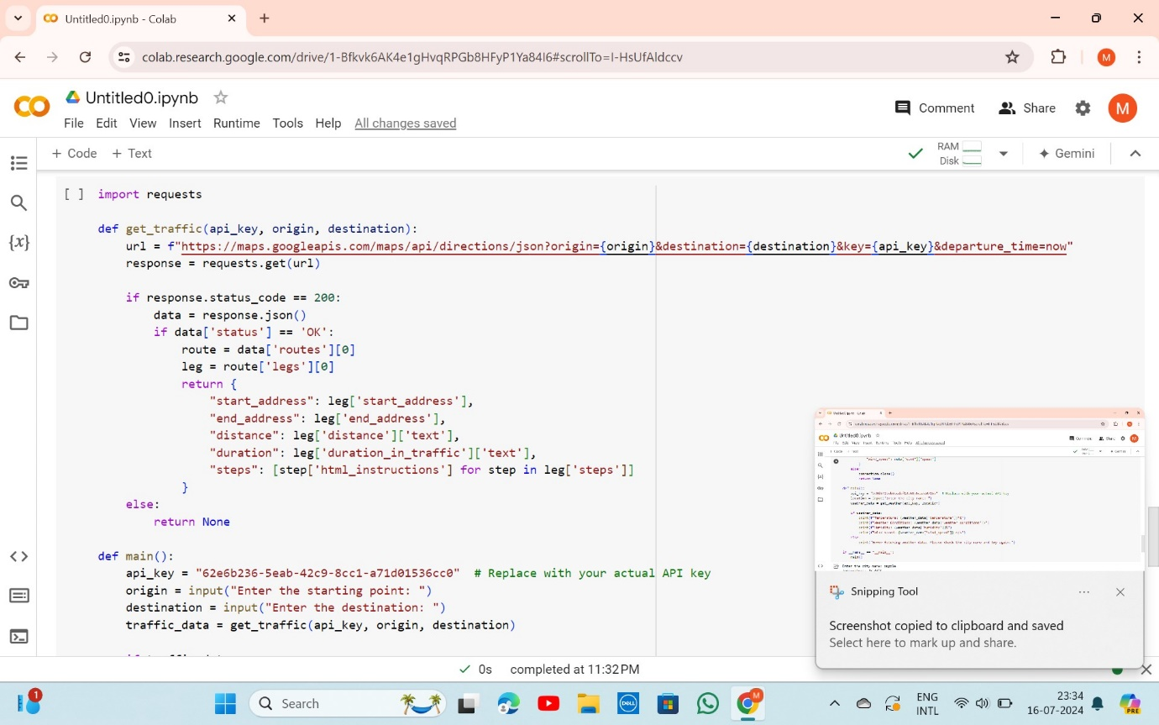

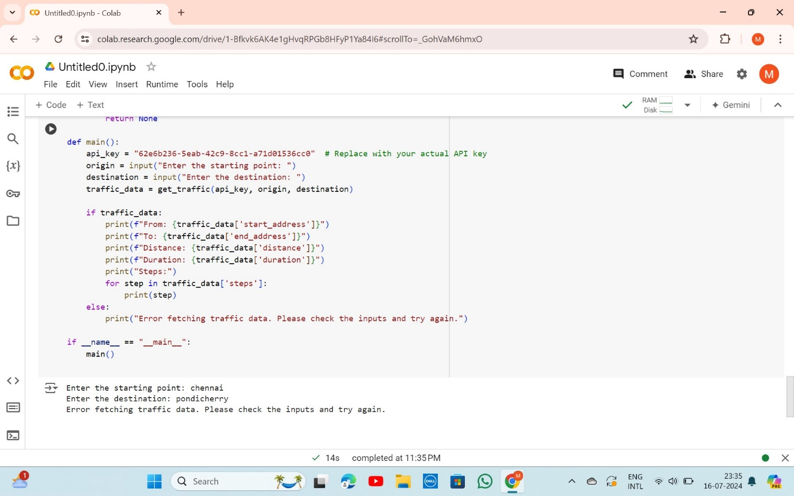

**Documentation:**

• **API Integration**: Using Google Maps Traffic API for real-time traffic data.

• **Methods**: The get traffic function handles API requests and response processing. The main function manages user input and displays traffic updates.

• **Assumptions**: Valid addresses provided by the user.

• **Improvements**: Enhance error handling, provide alternative routes, and integrate with other transportation modes.

**Problem 4: Real-Time COVID-19 Statistics Tracker**

**Scenario:**

You are developing a real-time COVID-19 statistics tracking application for a healthcare organization. The application should provide up-to-date information on COVID-19 cases, recoveries, and deaths for a specified region.

**Tasks:**

1. Model the data flow for fetching COVID-19 statistics from an external API and displaying it to the user.

2. Implement a Python application that integrates with a COVID-19 statistics API (e.g., disease.sh) to fetch real-time data.

3. Display the current number of cases, recoveries, and deaths for a specified region. 4. Allow users to input a region (country, state, or city) and display the corresponding COVID-19 statistics.

**Deliverables:**

• Data flow diagram illustrating the interaction between the application and the API.

• Pseudocode and implementation of the COVID-19 statistics tracking application.

• Documentation of the API integration and the methods used to fetch and display COVID19 data.

• Explanation of any assumptions made and potential improvements.

### Solution:

### Real-Time COVID-19 Statistics Tracker

### Data Flow Diagram:

### 

**Pseudocode:**

1. Get user input for the region.

2. Send a request to the COVID-19 statistics API with the region.

3. Receive and parse the COVID-19 data from the API.

4. Display the number of cases, recoveries, and deaths for the region.

**Implementation:**

import requests

def get_covid_stats(region, api_key):

    url = f"https://disease.sh/v3/covid-19/countries/{region}"

    headers = {

        "Authorization": f"Bearer {api_key}"

    }

    response = requests.get(url, headers=headers)

    if response.status_code == 200:

        data = response.json()

        return {

            "cases": data["cases"],

            "recoveries": data["recovered"],

            "deaths": data["deaths"]

        }

    else:

        return None

def main():

    region = input("Enter the country name: ")

    api_key = "a502e27681mshc78f31d182b7906p1f3ab2jsndff87578af3c"

    covid_data = get_covid_stats(region, api_key)

    if covid_data:

        print(f"COVID-19 Statistics for {region}:")

        print(f"Total Cases: {covid_data['cases']}")

        print(f"Recoveries: {covid_data['recoveries']}")

        print(f"Deaths: {covid_data['deaths']}")

    else:

        print("Error fetching COVID-19 data. Please check the region name and try again.")

if __name__ == "__main__":

    main()

**Output:**

Enter the country name: USA

COVID-19 Statistics for USA:

Total Cases: 111820082

Recoveries: 109814428

Deaths: 1219487

**User Input:**

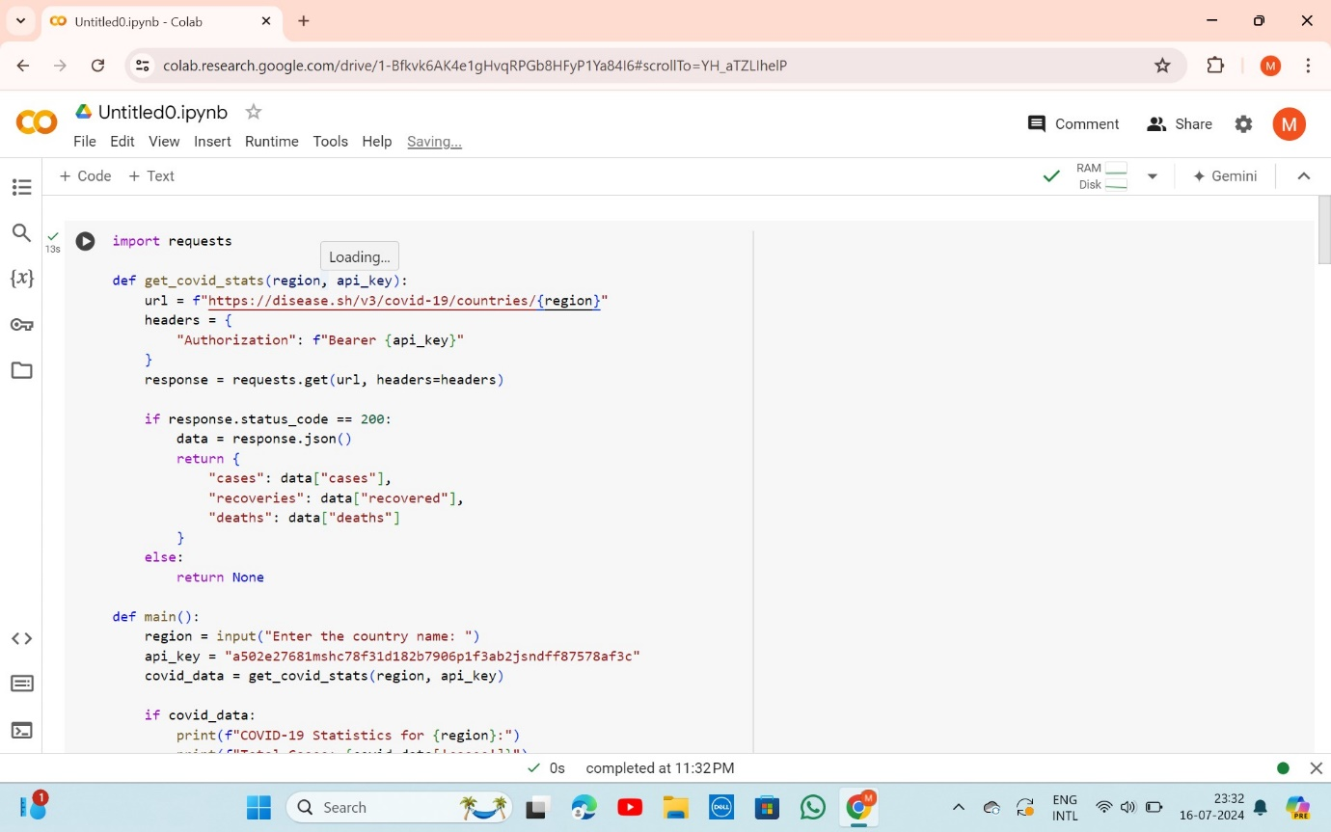

D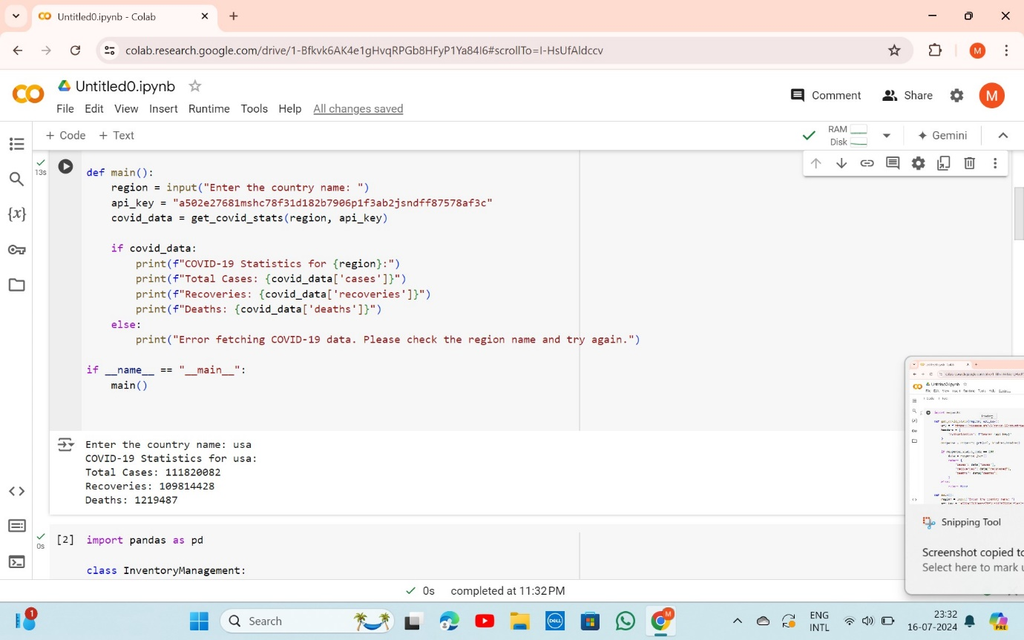

**Documentation:**

1. API Integration: Using disease.sh API for real-time COVID-19 statistics.
2. Methods: The get _covid _stats function handles the API request and response. The main function manages user input and displays statistics.
3. Assumptions: The user provides a valid country name.
4. Improvements: Enhance error handling, provide historical data, and integrate with vaccination statistics.